HR Attrition Analysis

Introduction
Employee attrition is one of the major challenges that organizations face because it can impact productivity, increase hiring costs, and affect team stability. Understanding the reasons behind employee turnover is important for improving employee satisfaction and retention.
In this project, we analyze the IBM HR Analytics Employee Attrition dataset to explore the key factors that influence employee attrition. The analysis focuses on identifying patterns and relationships between attrition and different employee characteristics such as age, income, overtime, and job role.
The project includes several steps such as data exploration, data cleaning, exploratory
data analysis (EDA), and machine learning modeling to build a predictive model that can estimate the likelihood of employee attrition.
The insights generated from this analysis can help HR departments make data-driven decisions to improve employee retention and organizational performance.

Project Objectives
- Analyze employee attrition patterns
- Identify factors that influence employee turnover
- Explore relationships between attrition and employee attributes
- Build a machine learning model to predict employee attrition

Import Libraries

In [1]:
# Import libraries for data analysis and visualization import pandas as pd
import numpy as np
import seaborn as sns
import matplotlib.pyplot as plt

Load Dataset

In [2]:
# Load the dataset
df = pd.read_csv(r"D:\gergess_magdy\Data Analysis\projects_Data_analysis\3_Python_p

# Display the first 5 rows df.head()

Out[2]:

Age | Attrition | BusinessTravel | DailyRate | Department | DistanceFromHome | Education
0 41 Yes Travel_Rarely 1102 Sales
1 | 2
8 | 1
2 | 2
3 | 4
2 | 1

1 49
No Travel_Frequently
279
Research & Development
2 37 Yes Travel_Rarely 1373 Research &
Development
3 33
No Travel_Frequently
1392
Research & Development
4 27 No Travel_Rarely 591 Research &
Development

5 rows × 35 columns

Data Overview

In [9]:
# Display dataset information (columns, data types, non-null counts) df.info()

# Display statistical summary of numeric columns df.describe()

<class 'pandas.core.frame.DataFrame'> RangeIndex: 1470 entries, 0 to 1469
Data columns (total 33 columns):
# Column Non-Null Count Dtype

0 Age | 1470 | non-null |  | int64
1 Attrition | 1470 | non-null |  | object
2 BusinessTravel | 1470 | non-null |  | object
3 DailyRate | 1470 | non-null |  | int64
4 Department | 1470 | non-null |  | object
5 DistanceFromHome | 1470 | non-null |  | int64
6 Education | 1470 | non-null |  | int64
7 EducationField | 1470 | non-null |  | object
8 EmployeeNumber | 1470 | non-null |  | int64
9 EnvironmentSatisfaction | 1470 | non-null |  | int64
10 Gender | 1470 | non-null |  | object
11 HourlyRate | 1470 | non-null |  | int64
12 JobInvolvement | 1470 | non-null |  | int64
13 JobLevel | 1470 | non-null |  | int64
14 JobRole | 1470 | non-null |  | object
15 JobSatisfaction | 1470 | non-null |  | int64
16 MaritalStatus | 1470 | non-null |  | object
17 MonthlyIncome | 1470 | non-null |  | int64
18 MonthlyRate | 1470 | non-null |  | int64
19 NumCompaniesWorked | 1470 | non-null |  | int64
20 Over18 | 1470 | non-null |  | object
21 OverTime | 1470 | non-null |  | object
22 PercentSalaryHike | 1470 | non-null |  | int64
23 PerformanceRating | 1470 | non-null |  | int64
24 RelationshipSatisfaction | 1470 | non-null |  | int64
25 StockOptionLevel | 1470 | non-null |  | int64
26 TotalWorkingYears | 1470 | non-null |  | int64
27 TrainingTimesLastYear | 1470 | non-null |  | int64
28 WorkLifeBalance | 1470 | non-null |  | int64
29 YearsAtCompany | 1470 | non-null |  | int64
30 YearsInCurrentRole | 1470 | non-null |  | int64
31 YearsSinceLastPromotion | 1470 | non-null |  | int64
32 YearsWithCurrManager | 1470 | non-null |  | int64
dtypes: int64(24), object(9) memory usage: 379.1+ KB

Out[9]: | Age |  | DailyRate | DistanceFromHome | Education | EmployeeNumber | Envir
 | count | 1470.000000 | 1470.000000 | 1470.000000 | 1470.000000 | 1470.000000
 | mean | 36.923810 | 802.485714 | 9.192517 | 2.912925 | 1024.865306
 | std | 9.135373 | 403.509100 | 8.106864 | 1.024165 | 602.024335
 | min | 18.000000 | 102.000000 | 1.000000 | 1.000000 | 1.000000
 | 25% | 30.000000 | 465.000000 | 2.000000 | 2.000000 | 491.250000
 | 50% | 36.000000 | 802.000000 | 7.000000 | 3.000000 | 1020.500000
 | 75% | 43.000000 | 1157.000000 | 14.000000 | 4.000000 | 1555.750000
 | max | 60.000000 | 1499.000000 | 29.000000 | 5.000000 | 2068.000000
8 rows × 24 columns

In [6]:
# Display the shape of the dataset (rows, columns) df.shape

Out[6]: (1470, 35)

In [5]:
# Count of unique values per column df.nunique()

Out[5]: | Age | 43
 | Attrition | 2
 | BusinessTravel | 3
 | DailyRate | 886
 | Department | 3
 | DistanceFromHome | 29
 | Education | 5
 | EducationField | 6
 | EmployeeCount | 1
 | EmployeeNumber | 1470
 | EnvironmentSatisfaction | 4
 | Gender | 2
 | HourlyRate | 71
 | JobInvolvement | 4
 | JobLevel | 5
 | JobRole | 9
 | JobSatisfaction | 4
 | MaritalStatus | 3
 | MonthlyIncome | 1349
 | MonthlyRate | 1427
 | NumCompaniesWorked | 10
 | Over18 | 1
 | OverTime | 2
 | PercentSalaryHike | 15
 | PerformanceRating | 2
 | RelationshipSatisfaction | 4
 | StandardHours | 1
 | StockOptionLevel | 4
 | TotalWorkingYears | 40
 | TrainingTimesLastYear | 7
 | WorkLifeBalance | 4
 | YearsAtCompany | 37
 | YearsInCurrentRole | 19
 | YearsSinceLastPromotion | 16
 | YearsWithCurrManager dtype: int64 | 18
In [7]: | # Check for missing values df.isna().sum()

Out[7]:

In [3]:
# Drop columns that are not useful for analysis
columns_to_drop = ['EmployeeCount', 'StandardHours', 'EmployeeNumber', 'Over18'] df = df.drop(columns=columns_to_drop, errors='ignore')

# Check the updated columns
print("Updated Columns:", df.columns.tolist())
Age 0
Attrition 0
BusinessTravel 0
DailyRate 0
Department 0
DistanceFromHome 0
Education 0
EducationField 0
EmployeeCount 0
EmployeeNumber 0
EnvironmentSatisfaction 0
Gender 0
HourlyRate 0
JobInvolvement 0
JobLevel 0
JobRole 0
JobSatisfaction 0
MaritalStatus 0
MonthlyIncome 0
MonthlyRate 0
NumCompaniesWorked 0
Over18 0
OverTime 0
PercentSalaryHike 0
PerformanceRating 0
RelationshipSatisfaction 0
StandardHours 0
StockOptionLevel 0
TotalWorkingYears 0
TrainingTimesLastYear 0
WorkLifeBalance 0
YearsAtCompany 0
YearsInCurrentRole 0
YearsSinceLastPromotion 0
YearsWithCurrManager 0
dtype: int64

Data Cleaning

Updated Columns: ['Age', 'Attrition', 'BusinessTravel', 'DailyRate', 'Department',
'DistanceFromHome', 'Education', 'EducationField', 'EnvironmentSatisfaction', 'Gende r', 'HourlyRate', 'JobInvolvement', 'JobLevel', 'JobRole', 'JobSatisfaction', 'Marit alStatus', 'MonthlyIncome', 'MonthlyRate', 'NumCompaniesWorked', 'OverTime', 'Percen tSalaryHike', 'PerformanceRating', 'RelationshipSatisfaction', 'StockOptionLevel',
'TotalWorkingYears', 'TrainingTimesLastYear', 'WorkLifeBalance', 'YearsAtCompany', 'YearsInCurrentRole', 'YearsSinceLastPromotion', 'YearsWithCurrManager']

In [4]:
# Convert Attrition column from text to numeric
df['Attrition'] = df['Attrition'].map({'Yes': 1, 'No': 0})

# Verify encoding
df['Attrition'].value_counts()

Out[4]:

In [10]:

Out[10]:

In [5]:
# Plot Attrition Distribution
sns.countplot(data=df, x='Attrition', color='skyblue') plt.title('Employee Attrition Distribution')
Attrition
0 1233
1 237
Name: count, dtype: int64
# Verify no missing values exist after cleaning df.isnull().sum()
Age 0
Attrition 0
BusinessTravel 0
DailyRate 0
Department 0
DistanceFromHome 0
Education 0
EducationField 0
EnvironmentSatisfaction 0
Gender 0
HourlyRate 0
JobInvolvement 0
JobLevel 0
JobRole 0
JobSatisfaction 0
MaritalStatus 0
MonthlyIncome 0
MonthlyRate 0
NumCompaniesWorked 0
OverTime 0
PercentSalaryHike 0
PerformanceRating 0
RelationshipSatisfaction 0
StockOptionLevel 0
TotalWorkingYears 0
TrainingTimesLastYear 0
WorkLifeBalance 0
YearsAtCompany 0
YearsInCurrentRole 0
YearsSinceLastPromotion 0
YearsWithCurrManager 0
dtype: int64
df.dtypes

Exploratory Data Analysis (EDA)

plt.xlabel('Attrition (0 = No, 1 = Yes)') plt.ylabel('Number of Employees')
plt.show()
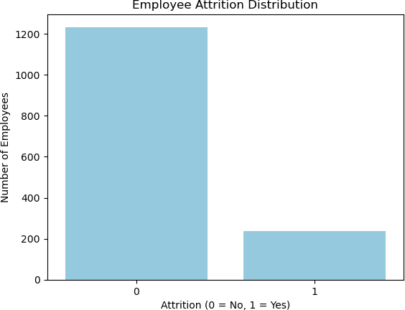

In [6]:
# Plot Attrition vs Age
sns.boxplot(x='Attrition', y='Age', data=df, color='lightgreen') plt.title('Attrition vs Age', fontsize=14)
plt.xlabel('Attrition (0 = No, 1 = Yes)', fontsize=12) plt.ylabel('Age', fontsize=12)
plt.show()

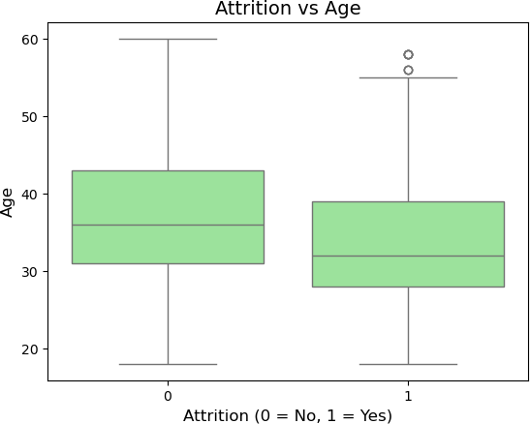

In [7]:
# Plot Attrition vs Monthly Income
sns.boxplot(x='Attrition', y='MonthlyIncome', data=df, color='lightcoral') plt.title('Attrition vs Monthly Income', fontsize=14)
plt.xlabel('Attrition (0 = No, 1 = Yes)', fontsize=12) plt.ylabel('Monthly Income', fontsize=12)
plt.show()

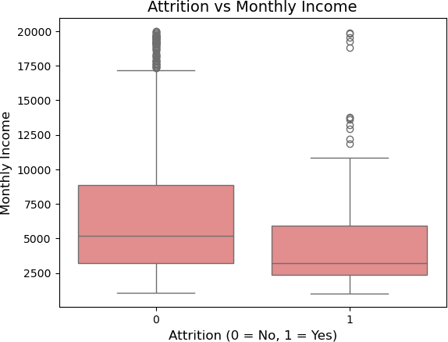

In [8]:
# Plot Attrition vs OverTime
sns.countplot(x='OverTime', hue='Attrition', data=df, palette='coolwarm') plt.title('Attrition vs OverTime', fontsize=14)
plt.xlabel('OverTime', fontsize=12)
plt.ylabel('Number of Employees', fontsize=12)
plt.legend(title='Attrition', labels=['No','Yes']) plt.show()

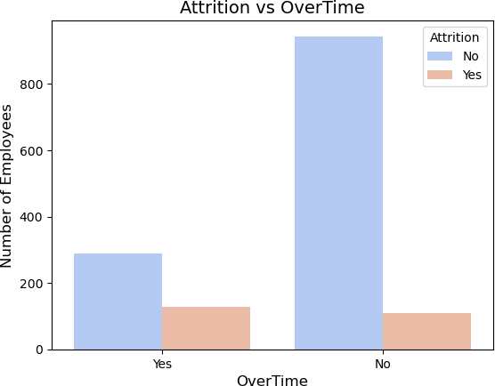

Correlation Analysis
To understand which features are most related to employee attrition, we calculated the correlation between all numerical variables and the target variable (Attrition).
The visualization below shows the top features that have the strongest relationship with employee attrition.

In [9]:
corr = df.corr(numeric_only=True)['Attrition'].sort_values(ascending=False)

corr

Out[9]: | Attrition | 1.000000
 | DistanceFromHome | 0.077924
 | NumCompaniesWorked | 0.043494
 | MonthlyRate | 0.015170
 | PerformanceRating | 0.002889
 | HourlyRate | -0.006846
 | PercentSalaryHike | -0.013478
 | Education | -0.031373
 | YearsSinceLastPromotion | -0.033019
 | RelationshipSatisfaction | -0.045872
 | DailyRate | -0.056652
 | TrainingTimesLastYear | -0.059478
 | WorkLifeBalance | -0.063939
 | EnvironmentSatisfaction | -0.103369
 | JobSatisfaction | -0.103481
 | JobInvolvement | -0.130016
 | YearsAtCompany | -0.134392
 | StockOptionLevel | -0.137145
 | YearsWithCurrManager | -0.156199
 | Age | -0.159205
 | MonthlyIncome | -0.159840
 | YearsInCurrentRole | -0.160545
 | JobLevel | -0.169105
 | TotalWorkingYears | -0.171063
 | Name: Attrition, dtype: | float64
In [10]: | top_corr = corr[1:16]
plt.figure(figsize=(8,6))

sns.barplot(
x=top_corr.values, y=top_corr.index
)
plt.title("Top Features Correlated with Attrition") plt.show()

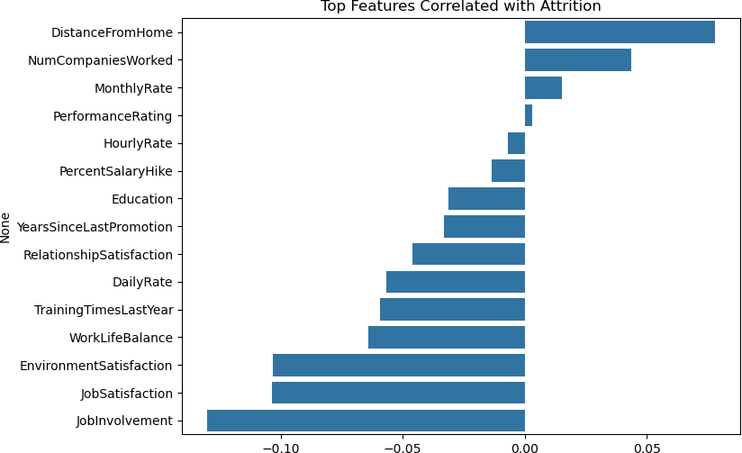

Key Insights from EDA
Based on the exploratory data analysis, here are the main observations regarding employee attrition:

Attrition Rate is Low
Most employees stayed with the company, with a smaller proportion leaving (Attrition = 1).

Younger Employees Tend to Leave More
Boxplots show that employees who leave are generally younger compared to those who stay.

Lower Monthly Income is Associated with Higher Attrition
Employees with lower salaries are more likely to leave, indicating pay is a key factor.

Overtime Increases Attrition Risk
Employees working overtime have a higher likelihood of leaving, suggesting workload affects retention.

Attrition is Less Dependent on Age after 40
Employees above 40 years old show a lower turnover rate, indicating stability with experience.

Work-Life Balance Factors May Influence Attrition
Although not directly visualized, the correlation with Overtime suggests that work-life

balance is important.

Insights Can Inform HR Decisions
These patterns can help HR focus on retention strategies, salary reviews, and overtime management.

Predicting Employee Attrition with XGBoost
In this section, we build a machine learning model using XGBoost to predict which employees are likely to leave the company.

In [21]:
# Import libraries
from sklearn.model_selection import train_test_split
from sklearn.metrics import accuracy_score, confusion_matrix, classification_report from imblearn.over_sampling import SMOTE
from xgboost import XGBClassifier

# Encode categorical variables
categorical_cols = df.select_dtypes(include=['object']).columns.tolist()
df_encoded = pd.get_dummies(df, columns=categorical_cols, drop_first=True)

# Separate features and target
X = df_encoded.drop('Attrition', axis=1) y = df_encoded['Attrition']

# Split into train and test sets (stratified)
X_train, X_test, y_train, y_test = train_test_split(X, y, test_size=0.2, random_sta

# Apply SMOTE on training data smote = SMOTE(random_state=42)
X_train_res, y_train_res = smote.fit_resample(X_train, y_train)

# Check class distribution
print("Before SMOTE:\n", y_train.value_counts())
print("After SMOTE:\n", y_train_res.value_counts())

Before SMOTE:
Attrition
0 986
1 190
Name: count, dtype: int64 After SMOTE:
Attrition
0 986
1 986
Name: count, dtype: int64

In [22]:
# Initialize and train XGBoost on balanced data xgb_model = XGBClassifier(
n_estimators=300, max_depth=6,
learning_rate=0.1,

random_state=42,
eval_metric='logloss'
)
xgb_model.fit(X_train_res, y_train_res)

Out[22]:
▾ XGBClassifier
i ?
Parameters

In [23]:
# Predict probabilities on test set
y_probs = xgb_model.predict_proba(X_test)[:, 1]

# Apply custom threshold threshold = 0.3
y_pred = (y_probs >= threshold).astype(int)

# Evaluate results
print("Accuracy:", accuracy_score(y_test, y_pred))
print("Confusion Matrix:\n", confusion_matrix(y_test, y_pred))
print("Classification Report:\n", classification_report(y_test, y_pred))

Accuracy: 0.8401360544217688
Confusion Matrix:
[[227 20]
[ 27 20]]

Classification | Report:  precision | recall | f1-score | support
0 | 0.89 | 0.92 | 0.91 | 247
1 | 0.50 | 0.43 | 0.46 | 47
accuracy |  |  | 0.84 | 294
macro avg | 0.70 | 0.67 | 0.68 | 294
weighted avg | 0.83 | 0.84 | 0.83 | 294

Feature Importance Analysis

In [24]:
# Create a dataframe for feature importance feature_importance = pd.DataFrame({
'Feature': X_train.columns,
'Importance': xgb_model.feature_importances_
})

# Sort features by importance
feature_importance = feature_importance.sort_values(by='Importance', ascending=Fals

# Show top 10 most important features feature_importance.head(10)

# Plot top 10 important features plt.figure(figsize=(10,6))

plt.barh(
feature_importance['Feature'].head(10),
feature_importance['Importance'].head(10)
)

plt.gca().invert_yaxis()

plt.title("Top 10 Most Important Features Influencing Employee Attrition") plt.xlabel("Importance Score")
plt.ylabel("Features")

plt.show()
Out[24]: | Feature |  | Importance
 | 15 | StockOptionLevel | 0.123562
 | 41 | MaritalStatus_Married | 0.072798
 | 26 | Department_Sales | 0.070440
 | 7 | JobLevel | 0.062096
 | 42 | MaritalStatus_Single | 0.061697
 | 33 | JobRole_Human Resources | 0.044742
 | 8 | JobSatisfaction | 0.042804
 | 25 | Department_Research & Development | 0.040448
 | 31 | EducationField_Technical Degree | 0.032943
 | 29 | EducationField_Medical | 0.027608
In [25]:

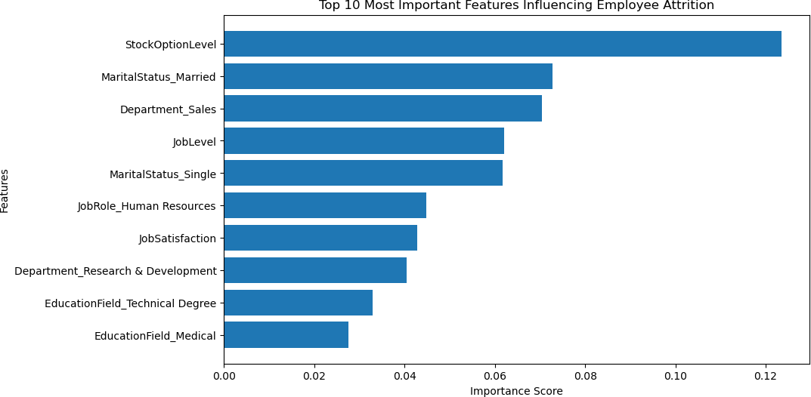

Key Drivers of Employee Attrition
Based on the XGBoost feature importance analysis, several factors appear to play a significant role in predicting employee attrition.

Stock Option Level
This is the most influential feature in the model. Employees with lower stock option benefits may be more likely to leave the company, suggesting that long-term financial incentives can improve retention.

Marital Status
Both "Married" and "Single" categories appear among the most important features, indicating that personal life circumstances may influence job stability and turnover behavior.

Department
Employees in the Sales and Research & Development departments show notable influence on attrition predictions. This may suggest different workload levels or career pressures across departments.

Job Level
Job level is an important factor, which may indicate that employees in certain seniority levels are more likely to leave due to career growth opportunities or job expectations.

Job Satisfaction
Lower job satisfaction is strongly associated with higher attrition risk, highlighting the importance of employee engagement and workplace satisfaction.

Education Field
Certain education backgrounds such as Technical Degree and Medical fields appear to influence attrition predictions, possibly reflecting varying job market demand for these skills.

Business Recommendations
Based on the analysis and machine learning results, several strategies can help reduce employee attrition:
  - Improve financial incentives such as stock options and compensation packages.

  - Monitor workload and overtime, especially in high-pressure departments like Sales.
  - Enhance job satisfaction through employee engagement programs.
  - Focus on retention strategies for employees in early career stages.
  - Provide career development opportunities and training programs.
Implementing these strategies can help organizations improve employee retention and reduce turnover.

